**SQL Queries used in Bank Report**

Total Loan Applications

select count(id) AS Total_loan_applications from financial_loan

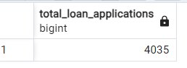

MTD Loan Applications

select count(id) AS Total_loan_applications from financial_loan

where Extract(Month from issue_date)=12

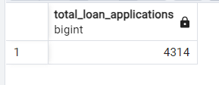

PMTD Loan Applications

select count(id) AS Total_loan_applications from financial_loan

where Extract(Month from issue_date)=11

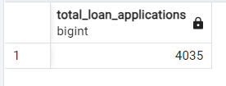

Total funded amount

Select sum(loan_amount) As Total_funded_amount

From financial_loan

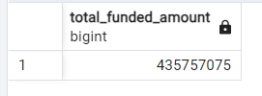

MTD Total funded amount

Select sum(loan_amount) As MTD_Total_funded_amount

From financial_loan

where extract(month from issue_date)=12

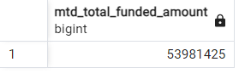

PMTD Total funded amount

Select sum(loan_amount) As PMTD_Total_funded_amount

From financial_loan

where extract(month from issue_date)=11

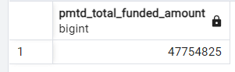

Total Amount Received

Select sum(total_payment) As Total_Amount_received

From financial_loan

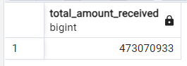

MTD Total Amount Received

Select sum(total_payment) As Total_Amount_received

From financial_loan

where extract(Month from issue_date)=12

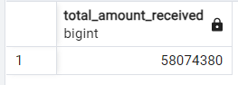

PMTD Total Amount Received

Select sum(total_payment) As Total_Amount_received

From financial_loan

where extract(Month from issue_date)=11

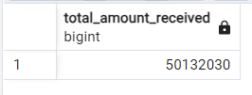

Average Interest Rate

select avg(int_rate)*100 as Average_interest_rate

from financial_loan

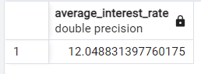

MTD Average Interest Rate

select avg(int_rate)*100 as Average_interest_rate

from financial_loan

where extract(month from issue_date)=12

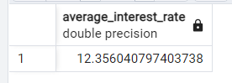

PMTD Average Interest Rate

select avg(int_rate)*100 as Average_interest_rate

from financial_loan

where extract(month from issue_date)=11

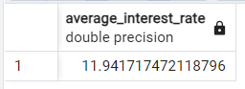

Average DTI

select avg(dti)*100 as Average_dti_rate

from financial_loan

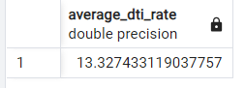

MTD Average DTI

select avg(dti)*100 as Average_dti_rate

from financial_loan

where extract(month from issue_date)=12

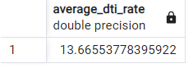

PMTD Average DTI

select avg(dti)*100 as Average_dti_rate

from financial_loan

where extract(month from issue_date)=11

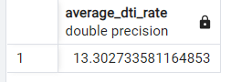

Good Loan Percentage

Select

(count(case when loan_status='Fully Paid' or loan_status='Current' then id END)*100

)/count(id) As Good_Loan_Percentage

from financial_loan

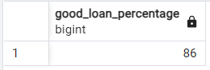

Good Loan Applications

select count(id) from financial_loan As Good_loan

where loan_status='Fully Paid' or loan_status='Current'

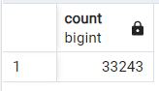

Good Loan Funded Amount

select

(sum(case when loan_status='Fully Paid' or loan_status='Current' then loan_amount END)

) as Good_loan_funded_amount

From financial_loan

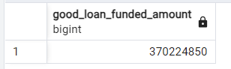

Good Loan Total Received Amount

select

(sum(case when loan_status='Fully Paid' or loan_status='Current' then total_payment END)

) as Good_loan_Received_amount

From financial_loan

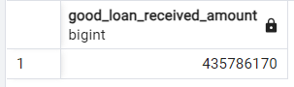

Bad loan percentage

select

(count(case when loan_status = 'Charged Off' then id END )*100.0

)/count(id) as Bad_loan_percentage

from financial_loan

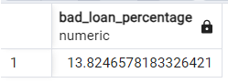

Bad Loan Applications

select count(id) from financial_loan As Bad_loan

where loan_status='Charged Off'

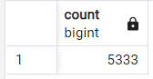

Bad Loan Funded Amount

select

(sum(case when loan_status='Charged Off' then loan_amount END)

) as Bad_loan_funded_amount

From financial_loan

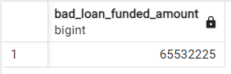

Bad loan Total Received Amount

select

(sum(case when loan_status='Charged Off' then total_payment END)

) as Bad_loan_received_amount

From financial_loan

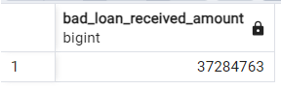

Bank Loan Report by Month

Select

Extract (Month from issue_date) as Month_number,

TO_CHAR(issue_date, 'Month') AS month_name,

count(id) as Total_loan_applications,

sum(loan_amount) as Total_funded_amount,

sum(total_payment) as Total_received_amount

from financial_loan

group by 1,2

order by 1

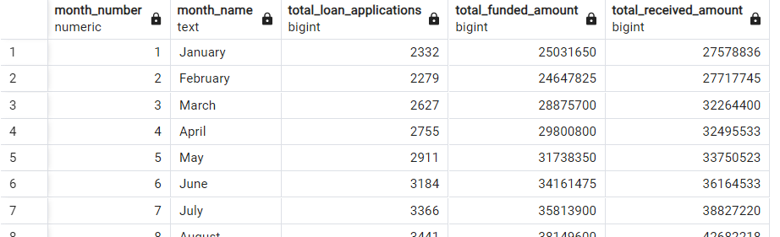

Bank Loan Report by State

Select

address_state as State,

count(id) as Total_loan_applications,

sum(loan_amount) as Total_funded_amount,

sum(total_payment) as Total_received_amount

from financial_loan

group by 1

order by 1

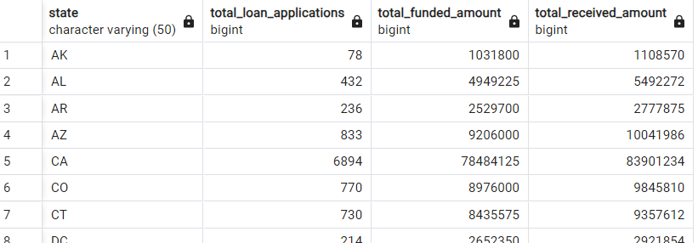

Bank Loan Report by Term

Select

term as Loan_Term,

count(id) as Total_loan_applications,

sum(loan_amount) as Total_funded_amount,

sum(total_payment) as Total_received_amount

from financial_loan

group by 1

order by 1 desc

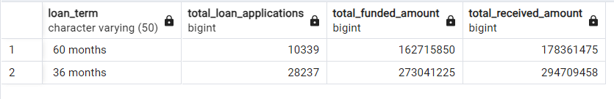

Bank Loan Report by Employee Length

Select

emp_length as Employee_length,

count(id) as Total_loan_applications,

sum(loan_amount) as Total_funded_amount,

sum(total_payment) as Total_received_amount

from financial_loan

group by 1

order by 1

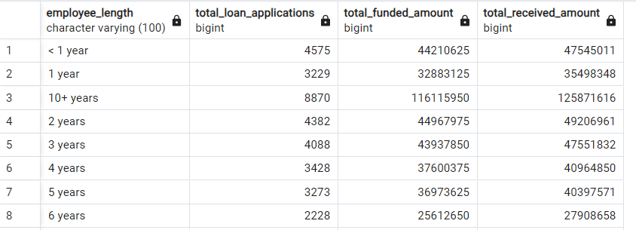

Bank Loan Report by Purpose

Select

purpose as Loan_purpose,

count(id) as Total_loan_applications,

sum(loan_amount) as Total_funded_amount,

sum(total_payment) as Total_received_amount

from financial_loan

group by 1

order by 1

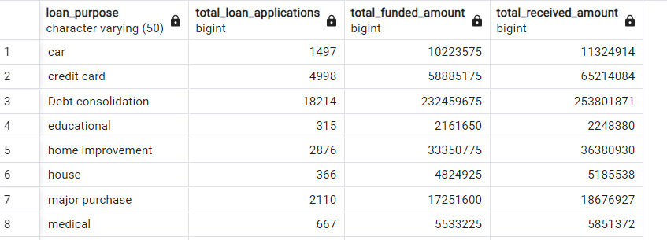

Bank Loan Report by Home Ownership

Select

home_ownership as Home_Ownership,

count(id) as Total_loan_applications,

sum(loan_amount) as Total_funded_amount,

sum(total_payment) as Total_received_amount

from financial_loan

group by 1

order by 1

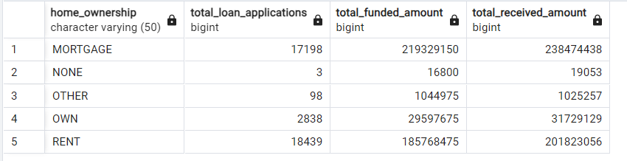

Loan Status Grid View

select

loan_status,

count(id) as LoanCount,

sum(total_payment) As total_amount_recieved,

sum(loan_amount) as Total_amount,

avg(int_rate*100) as Average_interest,

avg(dti*100) as DTI

from financial_loan

group by loan_status

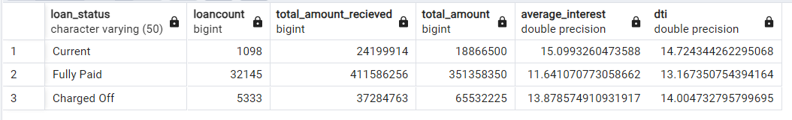

MTD Loan Status Grid View

select

loan_status,

sum(total_payment) As MTD_total_amount_recieved,

sum(loan_amount) as MTD_Total_loan_amount

from financial_loan

where extract(month from issue_date)=12

group by loan_status

